SUPPLEMENTAL DATA

Additional Data for Model Validation

Female Sprague-Dawley rat data of Pottenger et al. (2001). To test the parameters associated with the metabolism of ethylene glycol and the renal clearance of ethylene glycol and glycolic acid estimated from pregnant Sprague-Dawley rats for their applicability in non-pregnant female Sprague-Dawley rats, data from Pottenger et al. (2001) who also determined the kinetics of ¹³C₂-ethylene glycol in non-pregnant Sprague-Dawley rats administered either 10 or 2500 mg/kg by oral gavage were simulated. Pregnancy status did not appear to affect the pharmacokinetics of ethylene glycol and its metabolites. Therefore, simulations of the concentrations of ethylene glycol and glycolic acid in blood and urine using parameters estimated from pregnant rats are shown in Figure S-1. The concentrations of ethylene glycol and glycolic acid in blood and cumulative amounts excreted in the urine were reasonably well-described. However, following the low dose of ethylene glycol (10 mg/kg), no glycolic acid was detected above the limits of quantitation (2.1 mg/L). Simulations of glycolic acid at this dose level were consistent with this limitation. Slight differences were seen between simulations and the amounts of ethylene glycol and glycolic acid eliminated in the urine at the low dose, however, these differences were small (less than two-fold) and are likely due to the experimental variability (animal and analytical).
Male Sprague-Dawley rat data of Lenk et al. (1989). Partition coefficients, metabolism and renal clearance parameters estimated from female Sprague-Dawley rats were assumed to apply to all other genders and strains of rats, with the exception of male Wistar rats. As part of the validation of this assumption, simulations of the data of Lenk et al. (1989) who administered very high dose levels of ethylene glycol (3326 and 5544 mg/kg) by oral gavage to male Sprague-Dawley rats were performed. As shown in Figure S-2, the model provided an excellent description of the renal clearance of ethylene glycol and glycolic acid in the urine. Since the dose levels used in this study were exceptionally high, renal tubule reabsorption of glycolic acid was saturated. Thus, equivalent simulations of the cumulative amounts of glycolic acid excreted in the urine could be obtained using a first-order clearance term. However, as discussed above, such a simplification results in poor descriptions of the clearance of glycolic acid in urine at dose levels below 200 mg/kg.
Male Sprague-Dawley rat data of Hewlett et al. (1989). Hewlett et al. (1989) also administered high doses (2000 mg/kg) of ethylene glycol by oral gavage to male Sprague-Dawley rats. Simulations of concentrations of ethylene glycol and glycolic acid in the blood of rats from this study are shown in Figure S-3. The time to peak blood concentration of ethylene glycol was approximately one hr faster in the simulations than indicated by the data, which was surprising given the fact that the rats were fasted overnight prior to dosing. Reducing the first-order rate of absorption did little to improve the fit indicating a more complicated description of oral absorption may be necessary to describe this particular data set (e.g. a two-compartment gastrointestinal tract model). However, such additional complexity was not necessary for numerous other data sets; therefore, no adjustments were made to the model specifically to improve the fit to the data of Hewlett et al. The model also provided a reasonable simulation of the cumulative amount of ethylene glycol excreted in the urine during the first 12 hr (176 mg predicted vs. 105 mg observed) but significantly over-predicted the amount of glycolic acid eliminated at the same time (240 mg predicted vs. only 23 mg observed). Other than potential difficulties associated with the analysis of glycolic acid in biological samples, it is not clear why so little glycolic acid was found in the urine of the rats given that other studies performed in male and female Sprague-Dawley rats at similar dose levels resulted in the excretion of much higher levels of glycolic acid, similar to model predictions (see Lenk et al., 1989; Pottenger et al., 2001).
Male Wistar rat data of Richardson (1973). Richardson (1973) administered very high doses of ethylene glycol (6,823 mg/kg) or sodium glycolate (6,153 mg/kg) to male Wistar rats after 21 days on a vitamin B6-deficient diet to promote endogenous oxalate formation. Total amounts of oxalic acid and glyoxylic acid were determined in urine collected for 48 hr after dosing and these results were compared with model predictions of the total amounts of glycolic acid metabolized (Table S-1). Even though the potential impacts of such high doses of ethylene glycol and sodium glycolate and the B6-deficient diet on CO₂ production (see Figure 1, manuscript) are unknown and not accounted for in this study, the model predictions were within 33% of the observed amounts of glycolic acid metabolized by male Wistar rats.
Male and female F344 rat data of Marshall (1982). Marshall (1982) determined the dose-dependent disposition of ethylene glycol and its metabolites in male and female F344 rats administered ¹⁴C-ethylene glycol by intravenous injection at 20, 200, 1000 and 2000 mg/kg. Marshall was among the first to show a dose-dependent transition in glycolate kinetics that indicated saturation of metabolism occurs between 200 and 1000 mg/kg bolus administration of ethylene glycol (this was later confirmed by numerous investigators as summarized by Carney, 1994). Overall, the metabolism and urinary clearance parameters estimated from female Sprague-Dawley rats provided a reasonable description of the dose-dependent urinary clearance of ethylene glycol and glycolic acid in male and female F344 rats as shown in Table S-2.
Male albino rat data of McChesney et al., 1971). McChesney et al. (1971) administered a high dose of ¹⁴C-ethylene glycol (1109 mg/kg) to male albino rat by oral gavage and determined the total amounts of unmetabolized ethylene glycol eliminated in the urine over 24 hr. Using parameters for male Sprague-Dawley rats, simulations were generally within 10% of the data as shown in Table S-3.
McChesney et al. (1971) also administered 139 mg/kg ¹⁴C-ethylene glycol intravenously to male albino rats. The total amounts of ¹⁴C determined in tissues 1 hr after dosing were simulated assuming all radioactivity at this early time period was ethylene glycol, with the results shown in Table S-3. This simplifying assumption worked well for blood and kidney tissues, but significantly under-predicted the amounts of ¹⁴C in lung and liver tissues, indicating that metabolites other than ethylene glycol were present by 1 hr after dosing or incorrect assumptions were used regarding total tissue volumes for this unspecified strain of rat.
Male F344 and Wistar rat data of Cruzan et al. (2005). Cruzan et al. (2005) evaluated the comparative toxicity of ethylene glycol in male F344 and Wistar rats following dietary administration of 50, 150, 500 or 1000 mg/kg/day for up to 16 weeks. Subgroups of 5 rats/strain/dose level exposed to 150, 500 or 1000 mg/kg/day were housed for 24 hr in metabolism cages for the collection of urine then sacrificed for the collection of blood and kidneys following 1 and 16 weeks of exposure. Blood, kidneys and urine were analyzed for ethylene glycol, glycolic acid and oxalic acid. Ethylene glycol apparently acted as an osmotic diuretic as urine volumes from male F344 rats exposed to 1000 mg/kg/day and Wistar rats exposed to 500 and 1000 mg/kg/day were generally twice control levels by 16 weeks of exposure. Therefore, urine flows were increased over baseline levels shown in Table 4 (of Corley et al., 2005 manuscript) according to measured 24-hr values in simulations of each strain of rat.
Simulations of the total amounts of ethylene glycol and glycolic acid eliminated in 24-hr urine samples following 1 and 16 weeks of exposure are summarized in Table S-4. Using a simple 12 hr/day pulse dosing format also required the use of a fractional bioavailability of 0.75 for dietary uptake of ethylene glycol to provide the best description for all of the available data. Use of a fractional bioavailability of 1.0 resulted in significant over-predictions of the amounts of ethylene glycol and glycolic acid eliminated in urine as well as the terminal concentrations of ethylene glycol and glycolic acid in blood (and tissues); although these latter single point in time measurements are more affected by the time of necropsy (which was documented) vs. the assumed time of last consumption of the diets by individual animals (not documented) than by the fractional bioavailability. The use of a 0.75 fractional bioavailability from the diets, which is not necessary to simulate oral gavage studies, is also partially justified by the observations that extensive measures were required to efficiently extract ethylene glycol to confirm the concentrations, stability and homogeneity of the diet preparations used in their subchronic toxicity studies.
Following one week of dietary administration, simulations of the concentrations of ethylene glycol in blood and kidneys (Figures S-4 and S-5) and total amounts eliminated in the urine (Table S-4) of male F344 rats were consistent with the data. Blood levels of glycolic acid were also reasonably well-described at the high (1000 mg/kg) and low dose (150 mg/kg), but were consistently over-predicted for the middle dose (500 mg/kg) indicating that the metabolism of glycolic acid was not saturated at this dose (and dose-rate) as indicated by the model. At this intermediate dose level, model simulations are sensitive to the Km for the metabolism of glycolic acid, which was estimated from female Sprague Dawley rat data. Preliminary studies conducted in one of our laboratories (MJB) using liver S9 homogenates also indicate that male Wistar rats have a slightly lower Km than male F344 rats with even lower values determined for humans. Unfortunately, a direct comparison between glycolic acid in vitro metabolism rates using the same system (i.e., liver slice, cytosol or S9) in female Sprague Dawley rats and male F344 and Wistar rats is not currently available.
Similar results were obtained for male Wistar rats (Figures S-6 and S-7; Table S-4) with the exception that significantly less glycolic acid was eliminated in the urine than was predicted at the two higher dose levels (500 and 1000 mg/kg/day). This difference was attributed to oxalate-induced renal toxicity that is not accounted for in the PBPK model. The effects on the kidneys were even more significant following 16 weeks of exposure with male Wistar rats significantly more affected than male F344 rats. As shown in Figures S-4 to S-7 and Table S-4, renal toxicity following 16 weeks of exposure significantly impaired the ability of the rats to excrete ethylene glycol and/or its metabolites at 500 and 1000 mg/kg/day in F344 rats and 150, 500 and 1000 mg/kg/day in Wistar rats. Thus, PBPK simulations significantly over-predicted the amounts of ethylene glycol and/or glycolic acid eliminated in the urine and correspondingly under-predicted the concentrations in blood and kidney tissues at dose levels where renal toxicity was significant.
Figure S-1 Data (symbols) and model validations (lines) of the (a) concentration of ethylene glycol (EG) in blood; (b) concentration of glycolic acid (GA) in blood; (c) cumulative amounts of ethylene glycol eliminated in the urine; and (d) cumulative amounts of glycolic acid eliminated in the urine of female Sprague Dawley rats administered ethylene glycol by oral gavage at 10 or 2500 mg/kg (data from Pottenger et al., 2001). The levels of glycolic acid in blood following a 10 mg/kg oral dose of ethylene glycol were all below the limits of quantitation (2.1 mg/L, see dotted line).

(a)
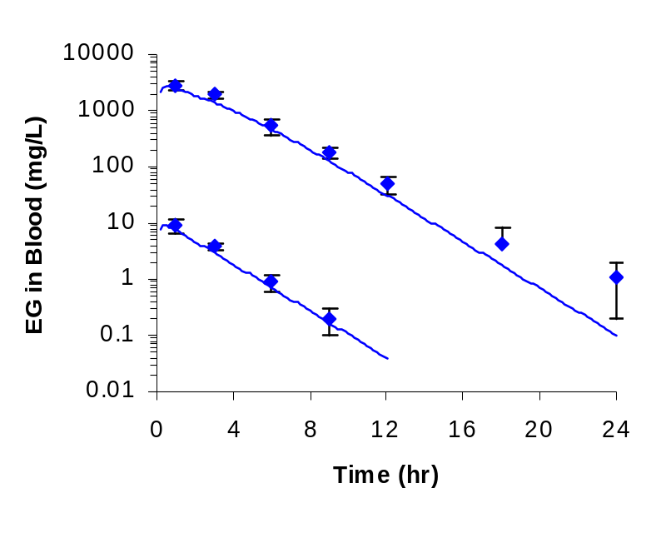

(b)

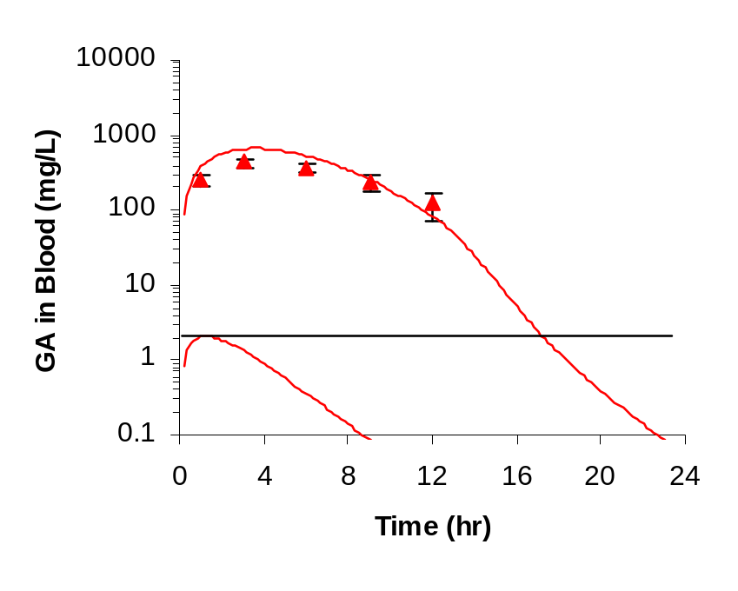

Figure S-1 (continued).

(c)
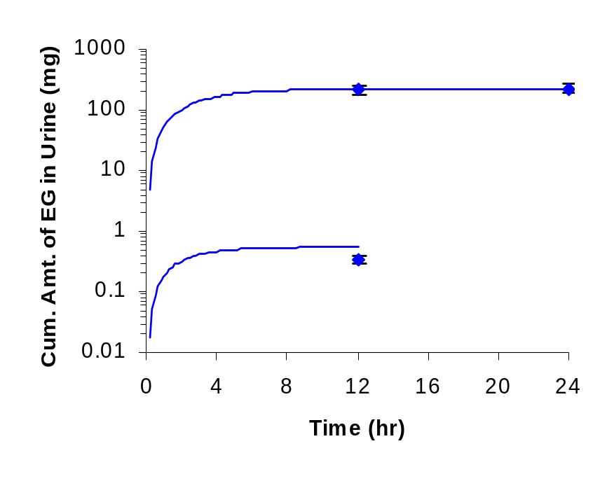

(d)
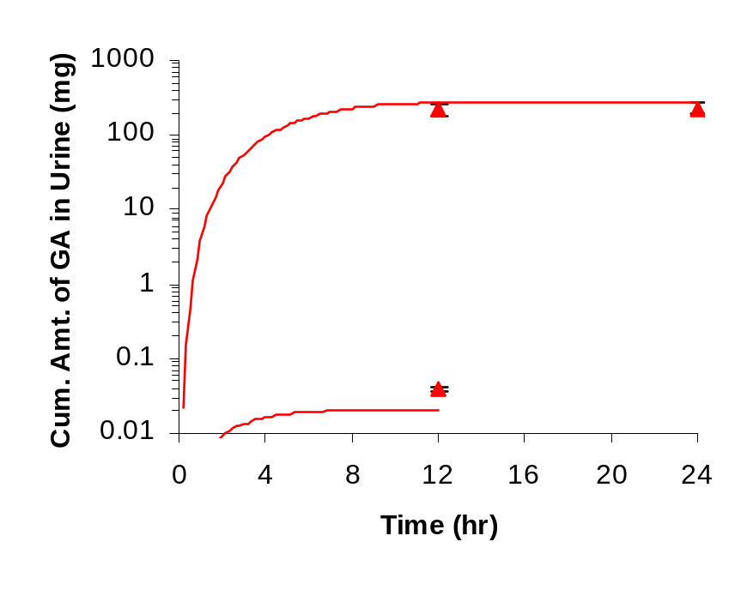

Figure S-2. Data (symbols) and model validations (lines) of the cumulative amounts of (a) ethylene glycol and (b) glycolic acid eliminated in the urine of male Sprague-Dawley rats administered either 3326 or 5544 mg/kg ethylene glycol by oral gavage (data from Lenk et al., (1989).

(a)
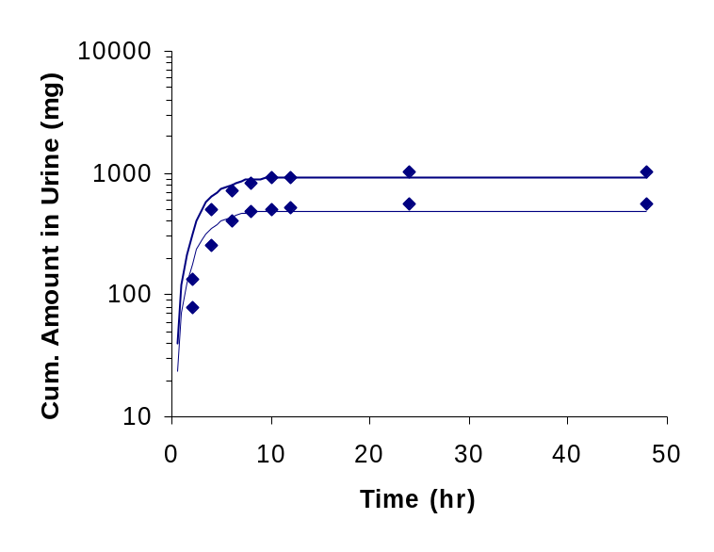

(b)
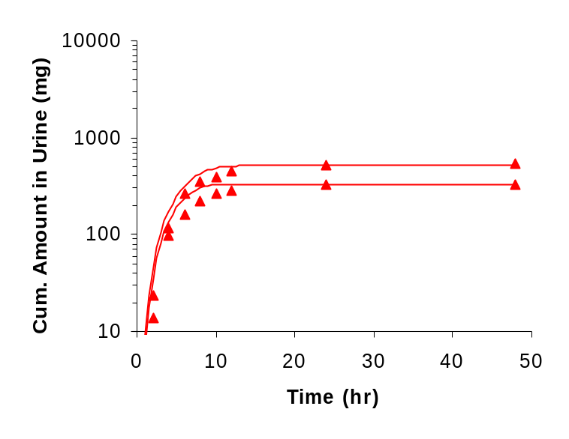

Figure S-3. Data (symbols) and model validations (lines) of the concentrations ethylene glycol and glycolic acid in blood of male Sprague-Dawley rats administered 2000 mg/kg ethylene glycol by oral gavage (data from Hewlett et al., 1989).

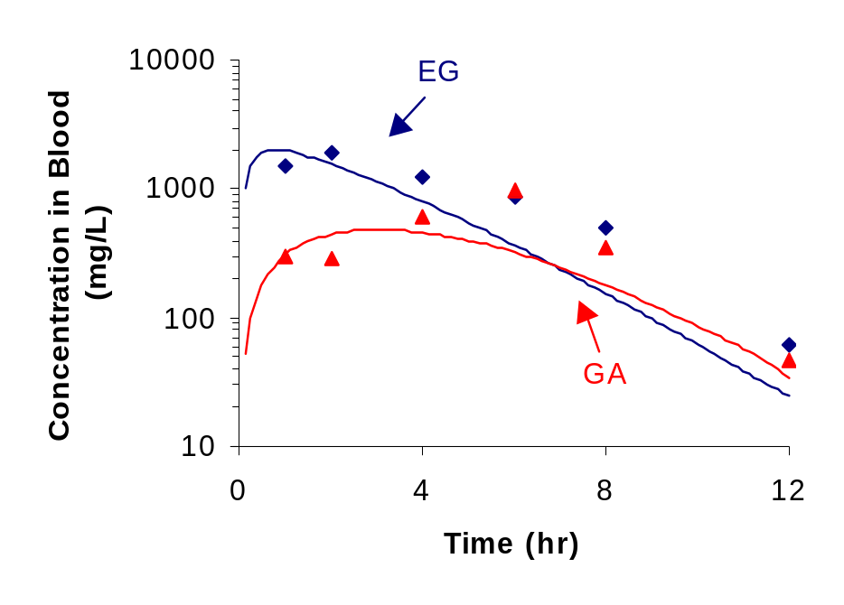

Figure S-4. Data (symbols) and model validations (lines) of the concentrations of (a) ethylene glycol and (b) glycolic acid in blood of male F344 rats administered either 150, 500 or 1000 mg/kg ethylene glycol via the diet for either one or 16 weeks (data from Cruzan et al., 2004). Only the final three days of each week’s simulations are shown.
(a)
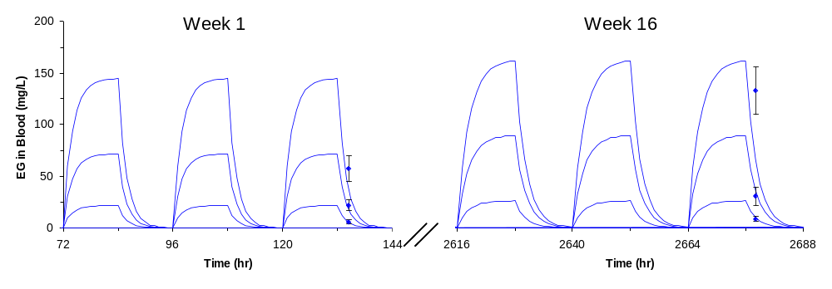

(b)

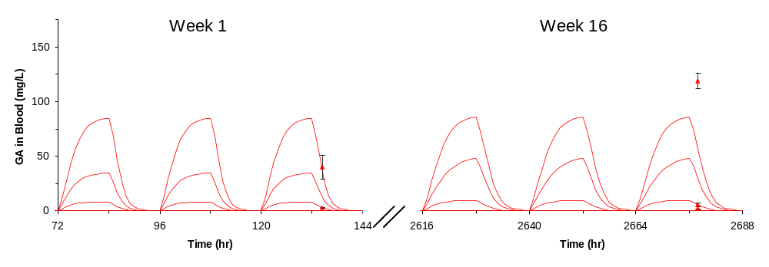

Figure S-5. Data (symbols) and model validations (lines) of the concentrations of (a) ethylene glycol and (b) glycolic acid in the kidneys of male F344 rats administered either 150, 500 or 1000 mg/kg ethylene glycol via the diet for either one or 16 weeks (data from Cruzan et al., 2004). Only the final three days of each week’s simulations are shown.

(a)
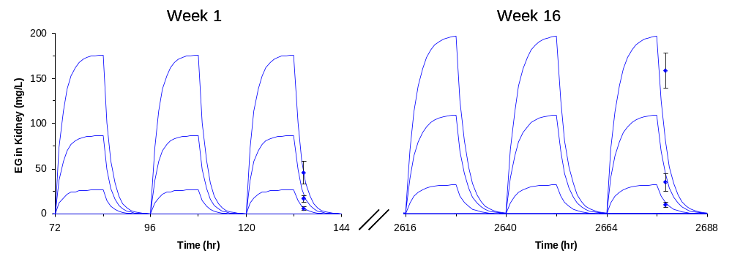

(b)
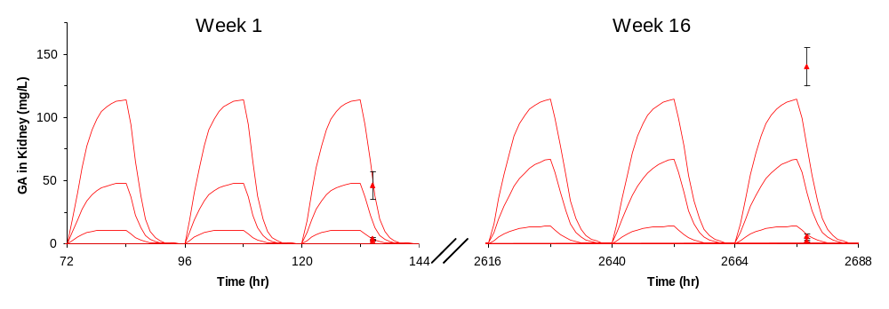

Figure S-6. Data (symbols) and model validations (lines) of the concentrations of (a) ethylene glycol and (b) glycolic acid in blood of male Wistar rats administered either 150, 500 or 1000 mg/kg ethylene glycol via the diet for either one or 16 weeks (data from Cruzan et al., 2004). Only the final three days of each week’s simulations are shown.
(a)
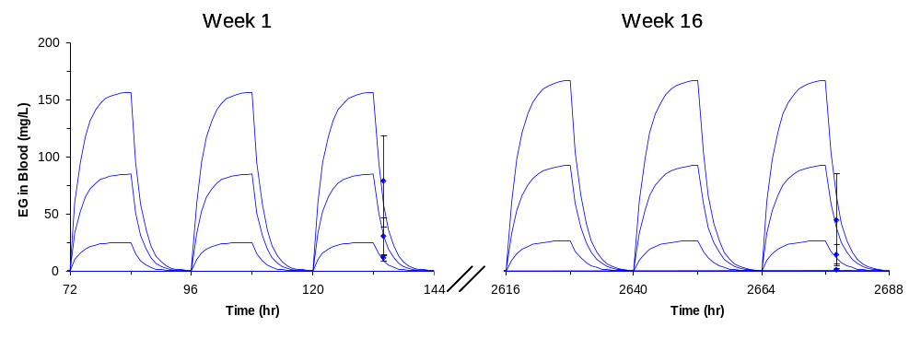

(b)
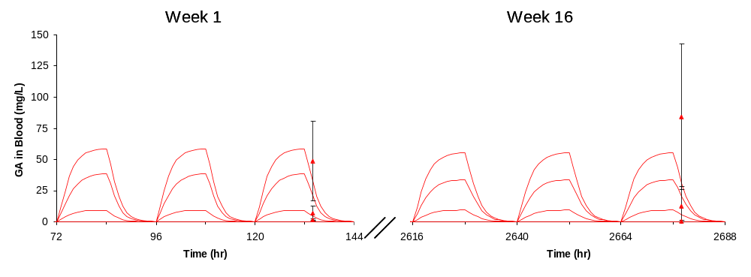

Figure S-7. Data (symbols) and model validations (lines) of the concentrations of (a) ethylene glycol and (b) glycolic acid in the kidneys of male Wistar rats administered either 150, 500 or 1000 mg/kg ethylene glycol via the diet for either one or 16 weeks (data from Cruzan et al., 2004). Only the final three days of each week’s simulations are shown.
(a)

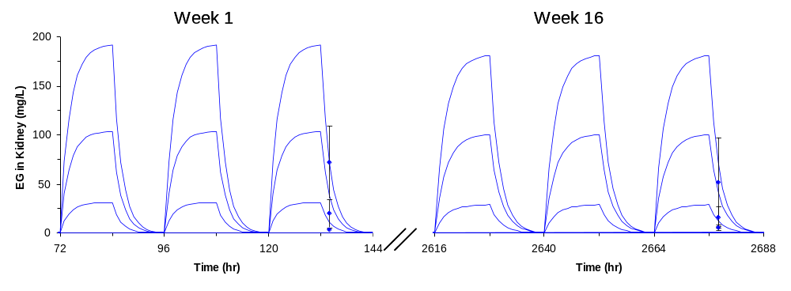
(b)
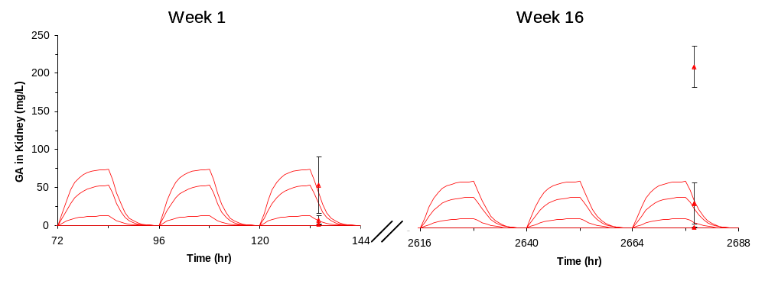

Table S-1. Total amounts of glycolic acid metabolized to glyoxylic acid and oxalic acid over 48 hr in the urine (observed) and simulations (predicted) of male Wistar rats administered 6,823 mg/kg ethylene glycol (EG) or 6,153 mg/kg sodium glycolate (NaG) by oral gavage while on a B6-deficient diet to promote endogenous oxalate formation (data from Richardson, 1973).

Observed Predicted Ratio
Chemical (mg Eq GA) (mg Eq GA) (Pred/Obs)
EG 255.4 340.1 1.33
NaG 250.4 182 0.73

Table S-2. Total amounts of ethylene glycol and glycolic acid eliminated over 24 hr in the urine (observed) and simulations (predicted) of male and female F344 rats administered ethylene glycol intravenously at dose levels of 20, 200, 1000 or 2000 mg/kg (data from Marshall, 1982).

Ethylene Glycol Glycolic Acid
Dose Obs, Pred, Ratio Obs, Pred, Ratio
Sex (mg/kg) (mg) (mg) (Pred/Obs) (mg) (mg) (Pred/Obs)
Male 20 1.445 1.241 0.86 0.074 0.0312 0.42
200 9.50 13.07 1.38 0.490 0.933 1.90
1000 46.75 78.26 1.67 59.16 83.81 1.42
2000 117.0 182.9 1.56 109.7 217.5 1.98

Female 20 0.897 0.808 0.90 0.036 0.022 0.61
200 10.66 8.50 0.80 0.797 0.434 0.54
1000 50.21 50.89 1.01 38.05 35.32 0.93
2000 108.6 118.9 1.10 83.7 112.9 1.35

Table S-3. Total amounts of ethylene glycol in tissues of male albino rats one hr (observed) and simulations (predicted) after an intravenous dose of 139 mg/kg ethylene glycol and total amounts of ethylene glycol eliminated in urine over 24 hr (observed) and simulations (predicted) of male albino rats administered 1109 mg/kg ethylene glycol by oral gavage (data from McChesney et al., 1971).

Dose Time Obs. Pred. Ratio
Route (hr) Sample (mg) (mg) (Pred/Obs)
IV 1 Blood 1.774 1.413 0.80
1 Lungs 0.275 0.117 0.43
1 Liver 2.660 0.742 0.28
1 Kidney 0.183 0.191 1.04

Oral 0-8 Urine 69.36 67.92 0.98
0-24 Urine 79.09 71.16 0.90

Table S-4. Total amounts of ethylene glycol and glycolic acid eliminated in the urine of male F344 and Wistar rats over 24 hr following either 1 or 16 weeks of exposure to ethylene glycol in the diets at either 150, 500 or 1000 mg/kg/day (data from Cruzan et al., 2005).

Ethylene Glycol Glycolic Acid
Diet Obs Pred Ratio Obs. Pred. Ratio
(mg/kg/day) Week (mg) (mg) (Pred/Obs) (mg) (mg) (Pred/Obs)

Male F344
150 1 5.13 4.23 0.82 0.36 0.18 0.50
500 1 14.51 13.42 0.93 1.21 1.02 0.84
1000 1 32.03 27.22 0.85 8.55 13.12 1.53

150 16 10.34 8.18 0.79 0.19 0.26 1.35
500 16 35.43 28.65 0.81 0.87 2.30 2.64
1000 16 59.90 49.72 0.83 5.62 31.95 5.69

Male Wistar
150 1 5.55 6.40 1.15 0.48 0.84 1.76
500 1 18.25 21.39 1.17 2.53 6.79 2.68
1000 1 24.81 38.57 1.55 9.71 41.30 4.25

150 16 8.23 10.57 1.28 0.23 1.11 4.90
500 16 8.29 31.57 3.81 0.34 21.55 63.39
1000 16 4.85 46.49 9.58 2.85 57.76 20.27

Model Equations

The PBPK model was structured assuming both ethylene glycol and glycolic acid are distributed “instantaneously” within each tissue (i.e., well-stirred compartments) dependent upon blood perfusion rates and the relative tissue:blood partition coefficients. Differential equations and abbreviations for the various tissue compartments are similar to those used by Andersen et al. (1987) and Corley et al. (1990). Thus, mass balance equations for each non-metabolizing or non-clearance tissue compartment followed the general format of:
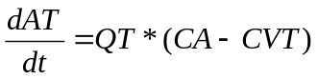 (1)
where AT is the amount of EG or GA in a given tissue T (mg), QT is the blood flow to that tissue (L/hr), CA is the arterial blood concentration of EG or GA (mg/L) and CVT is the concentration of EG or GA in venous blood draining the tissue (mg/L).
The concentration of EG or GA in venous blood draining the tissue (CVT, mg/L) is thus:
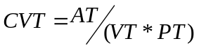 (2)
where VT and PT is the volume of the tissue (L) and the tissue:blood partition coefficient (unitless), respectively.
For a metabolizing tissue such as the liver, which receives both portal blood from the GI tract and arterial blood via the hepatic artery, and input from intraperitoneal dosing is described according to:
(3)
where AL is the amount of EG or GA in the liver (mg), QL is the total blood flow to the liver (L/hr), QGI is the blood flow to the GI tract (L/hr) which becomes portal blood flow to the liver, CVGI is the concentration of EG or GA in portal blood flow (a.k.a. venous blood draining the GI tissues), CVL is the concentration of EG or GA in venous blood draining the liver, RAML is the rate of metabolism of EG or GA (mg/hr), KIP is the first-order rate constant for the uptake of EG following intraperitoneal injection (hr⁻¹), and AIP is the amount of EG injected in the peritoneal cavity that is remaining to be absorbed by the liver (mg). To complete the description for intraperitoneal injection of EG, AIP is defined as:
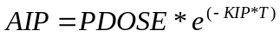 (4)
where PDOSE is the total amount of EG injected (mg).
The rate of metabolism in the liver (RAML) of EG or GA is described using the standard Michaelis-Menten format:
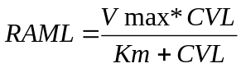 (5)
where Vmax is the enzyme capacity (mg/hr) and Km is the Michaelis constant (mg/L).
As stated above, these types of equations have been described in more detail previously (Andersen et al., 1987; Corley et al., 1990). Similar equations are used in other tissue compartments. Equations that are unique to this PBPK model describe the saturable reabsorption of the metabolite, GA, by the kidneys (see Figure 3, Corley et al., 2005 manuscript). In this refined model, the mass balance for the rate of change in the amount of GA in the kidneys (RAK, mg/hr) is described by:
RAK = RAKT + RATU (6)
where RAKT is the rate of change in the amount of GA in kidney tissues (mg/hr) and RATU is the rate of change in the amount of GA in tubule urine (mg/hr). These rates are defined further as:
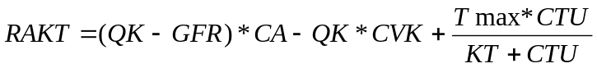 (7)
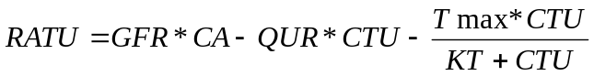 (8)
where QK is the blood flow to the kidney (mg/hr), GFR is the glomerular filtration rate (mg/hr; scaled as a fraction of the kidney weight), CVK is the concentration of GA in blood leaving the kidneys (mg/L), Tmax is the maximum rate for tubule reabsorption (mg/hr; scaled from BW^{0.70}), KT is the Michaelis constant for GA reabsorption (mg/L), CTU is the concentration of GA in tubule urine (mg/L), and QUR is the urine flow rate (L/hr; scaled as a fraction of kidney weight). Finally, the rate of elimination of GA in urine (RUGA; mg/hr) is calculated by:
RUGA=QUR*CTU (9)
Copies of the complete model source code written for SimuSolv®) can be obtained from the corresponding author upon request.

